**Storyboards**

***View All***

This task allows the user to view all events available in the database.

1. 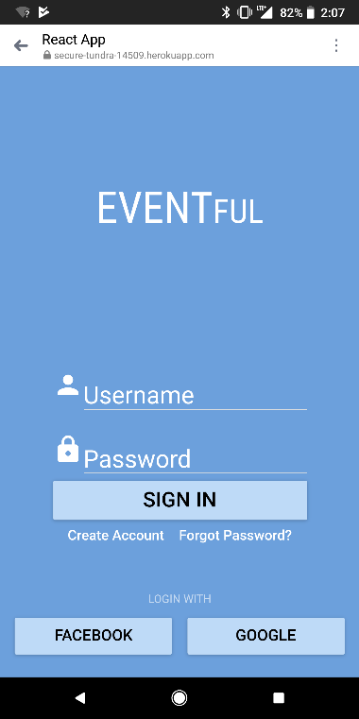Login into the application with a username/password or through Google/Facebook and click on “Sign In”



1. 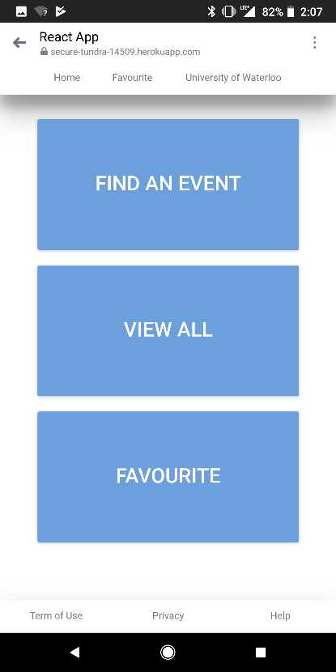Click on “View all” to view all available events



1. 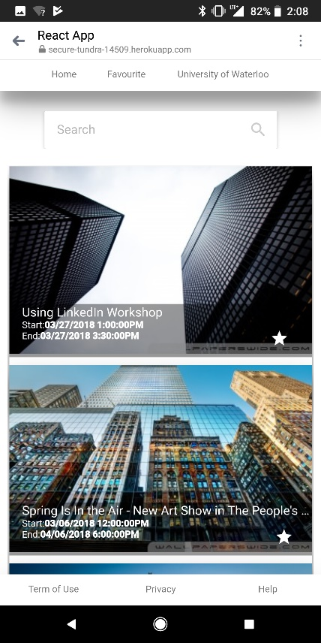You are now presented with all available events. You can scroll through them by swiping your finger up.

***Custom Search***

This task allows the user to custom search the results based off title and category. Once the results have been displayed, they can use the search bar to narrow down exactly what they’re looking for. To perform this task:

1. 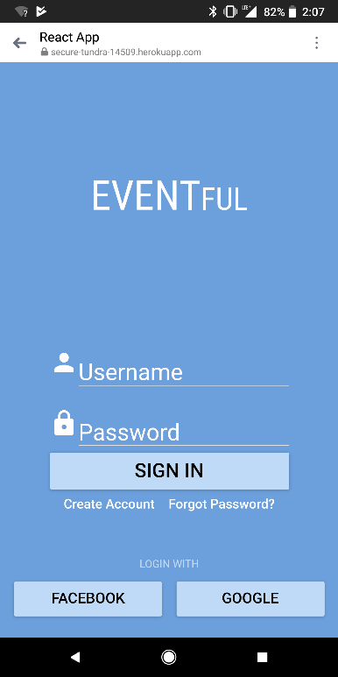Login into the application with a username/password or through Google/Facebook and click on “Sign In” (Back end is not actually implemented)



1. 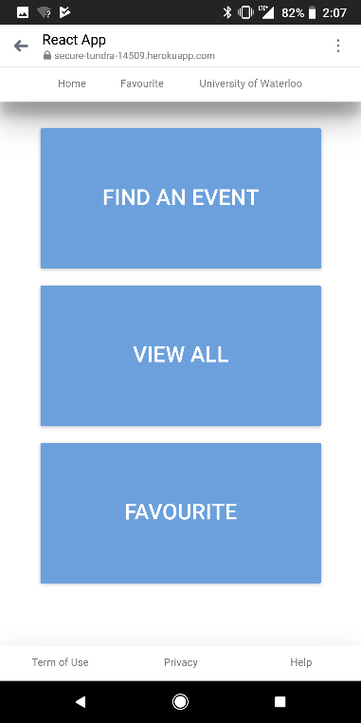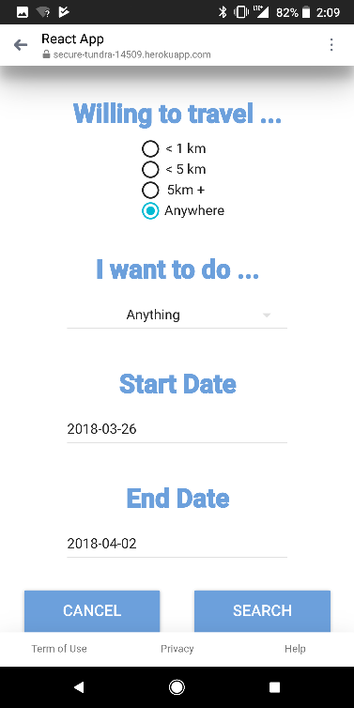a) Click on “View all” OR  
   b) Click on “Find an Event”, choose your options and then click on “Search”



1. Type in any part of a title or a category and the results will be updated in real time without having to click enter.

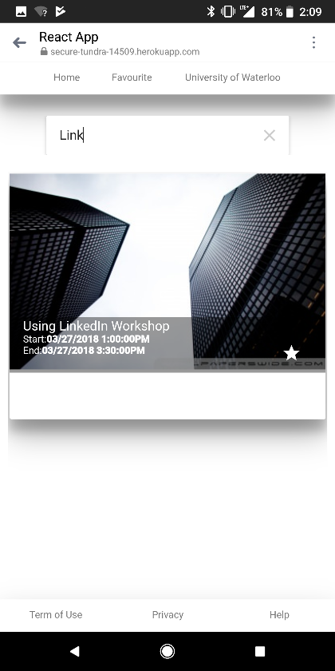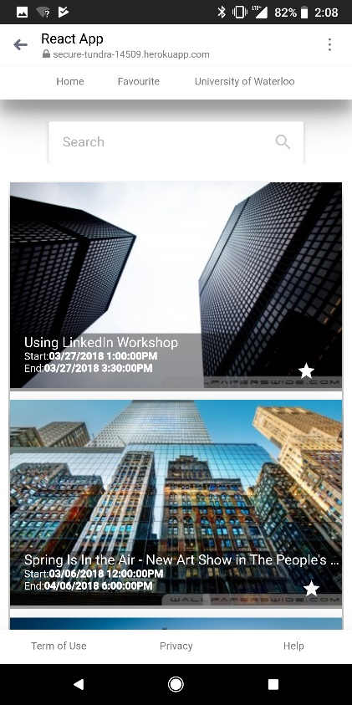



***Favourite Story Board***

A user can favourite events that he or she likes by pressing the star symbol on each event and then will be able to view it in the favourite section. To perform the following task:

1. Login into the application with a username/password or through Google/Facebook and click on “Sign In” (Back end is not actually implemented)



1. a) Click on “View all” OR  
   b) Click on “Find an Event”, choose your options and then click on “Search”



1. The user can click on the star to favourite an event. A notification pops up notifying that an event has been added to favourites.



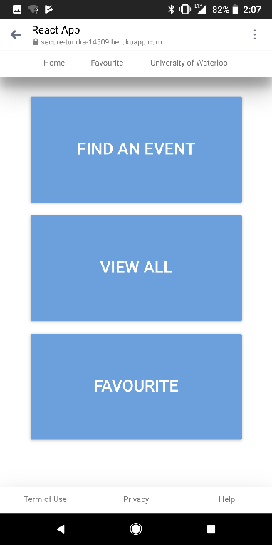

1. The user can either click on “Favourites” in the top header which would send them to the favourites tab or go back to the main page and clicks on the “Favourite” button.



1. The user can view their favorited events



***Search Querying***

The search querying allows the user to search events based on distance, dates, and/or category.

1. Login into the application with a username/password or through Google/Facebook and click on “Sign In” (Back end is not actually implemented)



1. The user first clicks on “Find An Event”

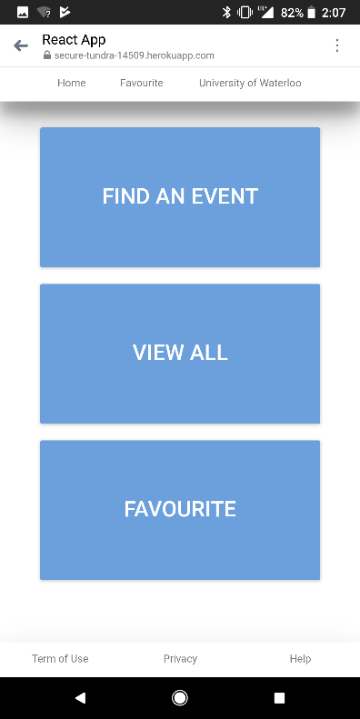



1. The user is prompted with a list of options. The user can select events based on how far he or she wants to travel.

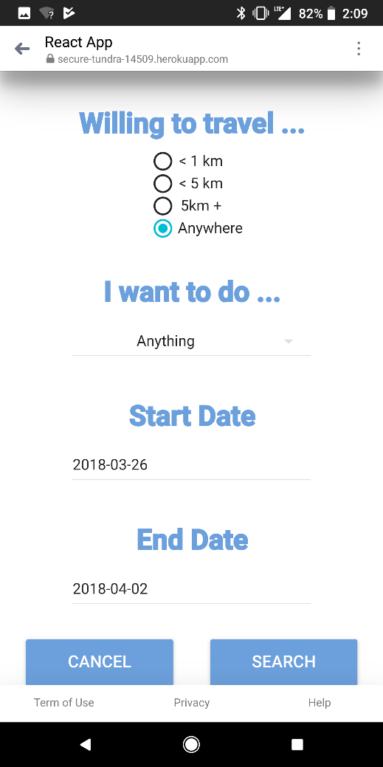



1. 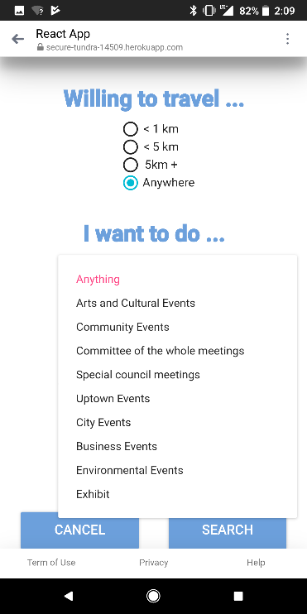The user can choose what type of events that they would like displayed.



1. 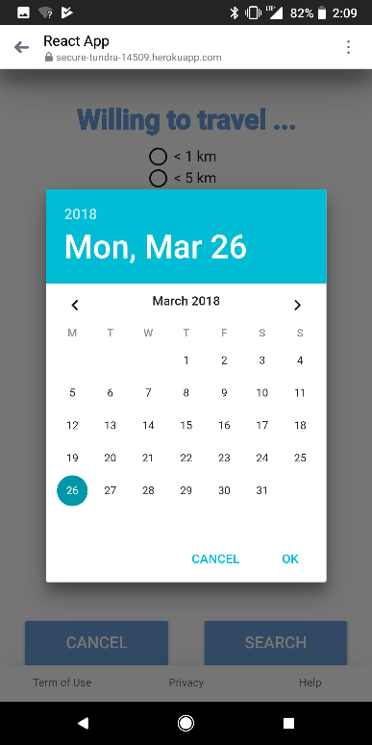The user can select the events that are happening within a certain timespan.



1. The user presses “Search” and the application asks if the user would like to share his or her location.

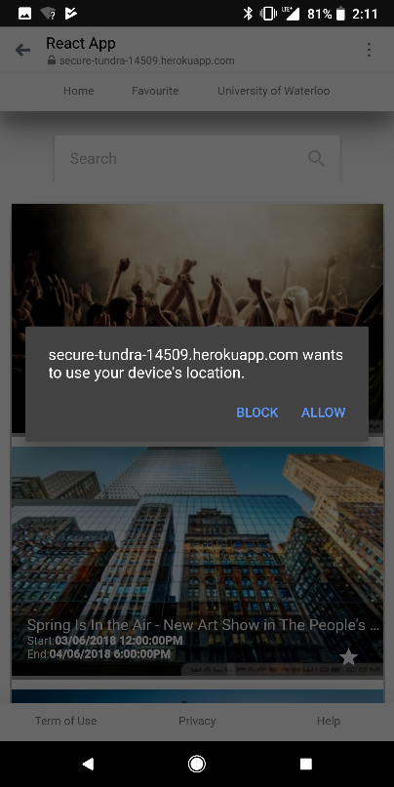



1. The user can view a list of events that satisfies the given set of user conditions.

**Database Creation Process**

For the database portion of the application, Firebase Realtime Database was chosen to host all the data. This is a noSQL database which provides real-time capabilities and is offered by Google. Being noSQL, it does not consist of tables and relationships; Instead its model is similar to a JSON tree. The reason why the decision was made to go with Firebase is because it is extremely scalable as more data is added. It also offers real-time capabilities, so any changes made to the database would be displayed instantly to the user. Firebase Database also has a very low setup cost to get it operational; there is no need to create any sort of ERD or DFD diagrams.

The model of the JSON tree has event id as the parent node with all the attributes being its child. The data was taken from The City of Waterloo’s API. The data was converted into a JSON format and then uploaded into firebase.

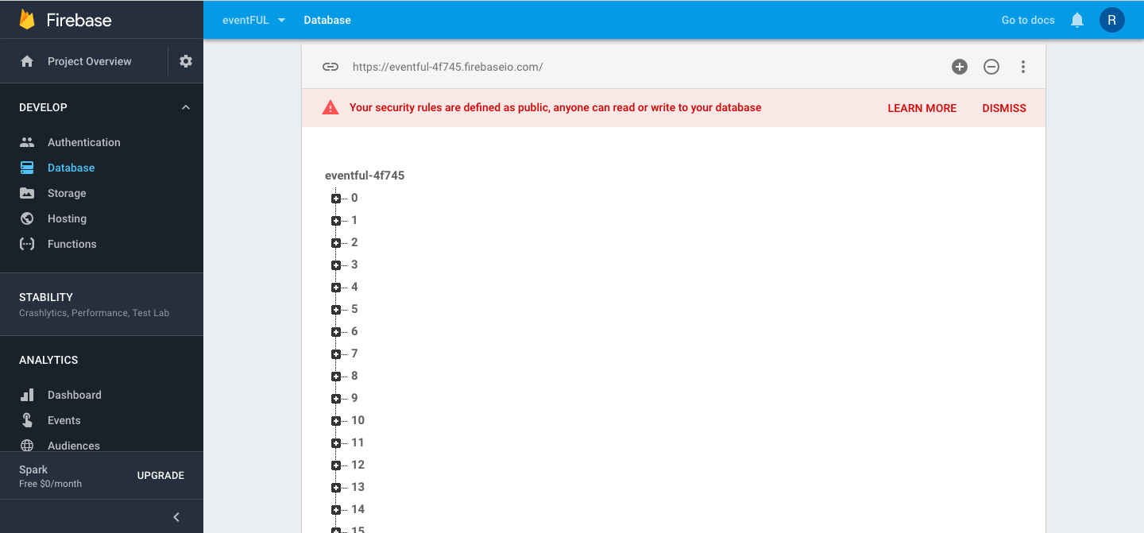

Each number represents the event id. Under each event id are its corresponding attributes

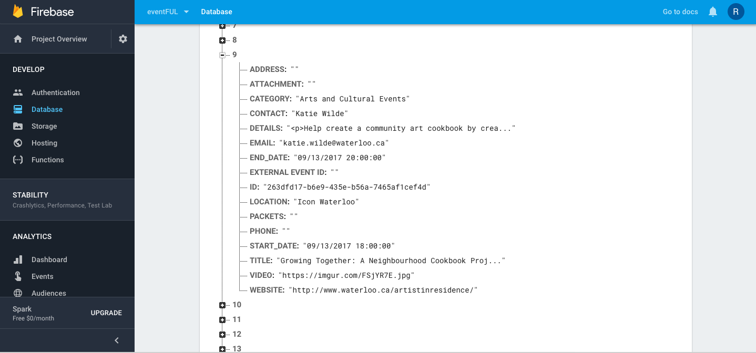

An example of one of the event's expanded. All the attributes are displayed like an object

ERD Diagram

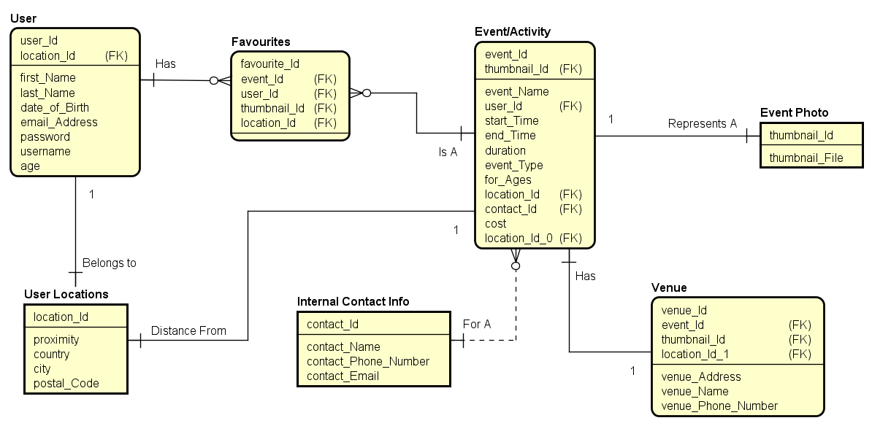

**Technical Specification**

By implementing ReactJS, all the querying and logic is moved to the frontend and therefore is able to make this application a single page application. No matter where the user goes on the web application, the browser page will not reload. Therefore, this attribute has the highest level of performance and scalability.

The backend is firebase as querying the data from the database happens on the frontend using JavaScript.

During the implementation process, the application is broken down into atomic reusable components. In other words, the same button component is used through the application. However, each button performs different functionalities.

Another key feature worth mentioning is that, this entire application is built on one HTML div tag as shown below:



Google maps distance matrix API was implemented to retrieve the user’s current location and tell the user how far he or she is from each event.



The structure of the application is heavily object oriented. This will result in efficient maintainability. For example, when features are added, they will be treated as objects and that means adding features will not break other features. Each application is not dependent on the other. A folder structure shown below can demonstrate this process.



**Future Recommendations**

By developing this prototype, many potential features can be implemented. As the development process progresses, the capability of developing an enhanced recommender system can be used to help users recommend certain events based on each user’s profile. Another feature can be letting the user create their own event and have it submitted for review to become one of the events on the data base. The owner of each event may see how many favourites their event(s) have and perform data analysis for business modelling.

Side note: The data consisted of hundreds of events that have not been populated with images and certain distances. The team had to manually populate the hundreds of data and therefore some distances and images corresponding with their event title will be off.

**Appendix:**

All the pictures from the application are listed before



